Safety Evaluation of Generative Driving Videos
Authors: Xingjia Yang, Jin Shan, Jie Lin

Introduction
The rapid development of generative video models, especially world models and diffusion-based systems, has created new opportunities for autonomous driving simulation. Models such as DriveDreamer, MagicDrive, and Panacea can generate realistic, multi-view, and controllable driving videos from real-world data, making them useful for scalable training and evaluation of autonomous driving systems.

However, visual realism does not necessarily guarantee safety or consistency. Generated driving videos may contain semantic errors, logical inconsistencies, or unsafe decision-level behaviors, especially under physically conditioned or adversarial perturbations. In safety-critical domains such as autonomous driving, these failures are not merely visual artifacts. Missing traffic objects, inconsistent motion, incorrect traffic signals, or unsafe ego-vehicle behavior may lead to misleading evaluation results and weaken the reliability of downstream validation.

This project develops a structured evaluation framework for analyzing safety failures in generated autonomous driving videos. Instead of relying only on visual quality, we evaluate whether the generated results preserve traffic-relevant semantics, temporal and physical logic, and safe driving decisions. The framework combines human annotation with LLM-based evaluation using Gemini, OpenAI, and Claude, and compares their outputs through poisoned-label accuracy, attack-level agreement, and score-level RMSE.

The goal of this study is to examine whether LLMs can serve as scalable assistants for safety evaluation, while also identifying their limitations compared with human judgment. The results provide evidence for how prompt design and model selection affect automated evaluation reliability in generative autonomous driving scenarios.

Literature Review

Recent progress in generative world models has expanded the role of video generation in autonomous driving simulation. DriveDreamer demonstrates that diffusion-based world models can learn from real-world driving data and generate controllable future driving scenes. MagicDrive further improves controllable street-view generation by incorporating 3D geometric conditions such as camera pose and 3D bounding boxes, making the generated scenes more useful for perception-related tasks. Panacea extends this direction to panoramic and temporally consistent video generation by modeling both cross-view and cross-frame relationships. Together, these studies show that generative models can produce realistic and controllable driving videos, but they also raise an important question: whether visually plausible generated videos are logically consistent and safe enough for autonomous driving evaluation.

Safety evaluation in autonomous driving requires more than measuring visual quality. A generated scene may look realistic while still containing missing traffic objects, inconsistent object motion, incorrect road structure, or unsafe driving behavior. Therefore, evaluation should consider traffic semantics, temporal logic, physical plausibility, and decision-level safety. These requirements motivate a more structured annotation framework instead of relying only on image similarity or perceptual realism metrics.

LLM-based evaluation provides a possible scalable solution for this type of complex judgment. Prior work such as G-Eval shows that large language models can approximate human evaluation when guided by structured prompts and form-based outputs. Similarly, MT-Bench and Chatbot Arena demonstrate that strong LLMs can act as judges for open-ended tasks with relatively high agreement with human preferences. However, most existing LLM-as-judge studies focus on language or general preference evaluation rather than safety-critical visual reasoning in autonomous driving videos.

This project builds on these three directions. It uses the safety concerns raised by generative driving models, combines them with a human-defined taxonomy of semantic, logical, and decision-level failures, and investigates whether LLMs can serve as reliable evaluators for generated driving videos under physically conditioned attacks.

Dataset and Task Definition
This project evaluates safety failures in generated autonomous driving videos. The main task is to determine whether each generated video contains a physically conditioned attack or safety-relevant generation error, and if so, to classify the dominant failure type. The evaluation focuses on three attack levels: semantic, logical, and decision-level failures.

Semantic-level failures refer to incorrect rendering or disappearance of traffic-relevant elements. Examples include missing or malformed vehicles, pedestrians, traffic lights, road signs, lane markings, or road boundaries. These errors mainly affect whether the generated scene preserves the key visual information required for driving understanding.

Logical-level failures refer to violations of temporal consistency, physical plausibility, or object permanence. Typical cases include sudden object disappearance, physically impossible object positions, unstable trajectories, unrealistic acceleration, or inconsistent motion across frames. These errors indicate that the generated video does not follow reasonable physical or temporal logic.

Decision-level failures refer to unsafe or incorrect driving behavior implied by the generated result. Examples include failing to slow down at intersections, ignoring traffic signals, unsafe lane changes, or continuing forward when yielding is required. These failures are the most safety-critical because they suggest an incorrect driving response rather than only a visual or temporal artifact.

The dataset contains 100 multi-view autonomous driving video samples. Each sample consists of 8 temporal frames and 6 camera views: Front-Left, Front, Front-Right, Rear-Left, Rear, and Rear-Right. In each frame, the Ground Truth is shown at the top, the 3D Box Map in the middle, and the Generated Result at the bottom. The dataset includes both clean and unsafe samples, with the human annotation showing that around 30% of the videos are poisoned. This structure allows us to compare human and LLM-based evaluations under the same task definition.

Methodology

Human Labeling
Human labeling was conducted on 100 evaluation videos. Each video contains 8 frames and 6 camera views: Front-Left, Front, Front-Right, Rear-Left, Rear, and Rear-Right. In each frame, the Ground Truth is shown at the top, the 3D Box Map in the middle, and the Generated Result at the bottom.
Our labeling process mainly followed a difference-first strategy. For each video, we first compared the Generated Result with the Ground Truth to locate visible discrepancies. After identifying these differences, we then determined whether they mainly belonged to semantic-level, logic-level, or decision-level errors.
For semantic-level labeling, we focused on changes to key traffic elements, such as vehicles, pedestrians, traffic lights, and lane markings. If the main problem was blurring, disappearance, or incorrect generation of these elements, the sample was labeled as semantic-level.
For logic-level labeling, we focused on temporal consistency and physical plausibility across frames. Typical indicators included objects disappearing during motion, physically implausible positions, and highly unstable trajectories with inconsistent velocity or angular velocity. Because each video only contains 8 frames, logic-level errors were labeled conservatively and only when the inconsistency was sufficiently clear.
For decision-level labeling, we focused on whether the generated video implied an incorrect or unsafe driving response. Typical cases included failing to slow down at intersections, accelerating when yielding was required, ignoring traffic signals, or changing lanes unsafely. When both visual corruption and unsafe behavior were present, the dominant safety risk was used as the final label.
In practice, a video could contain multiple anomalies at the same time. Therefore, we applied a dominant-error principle and assigned one final attack level to each sample. This made the annotation process more consistent and easier to compare with automated evaluation results.

LLM Labeling
We used three large language models as automated evaluators: Gemini, OpenAI GPT, and Claude Opus 4.7. Their role was not to generate videos, but to inspect each driving sample and assign safety labels following the annotation guideline. For every video, the model needed to decide whether the generated result was poisoned, classify the attack level as None, Semantic, Logic, or Decision, and provide three sub-scores (semantic, logical, and decision) together with a final score and a short explanation.

The model input was designed to preserve the original evaluation context of the dataset. Each sample contains 8 temporal frames, and each frame includes three aligned parts: Ground Truth, 3D Box Map, and Generated Output, across six camera views. Depending on the model interface, the visual input was provided either as the full video or as extracted chronological frames. For OpenAI, since our pipeline did not directly use the raw video file as the main evaluation unit, we first extracted 8 chronological frames from each video and then sent these frames, along with the guideline document, to the model for evaluation. This ensured that the temporal order and multi-view structure were still available to the evaluator.

The prompt was designed to be explicit and highly structured. It first described the video layout and defined the three attack levels according to the guideline. It then instructed the model to output exactly one label instance for each video, including video_id, is_poisoned, attack_level, score fields, final score, and reasoning. To reduce ambiguity, the prompt also specified logical constraints, for example: if is_poisoned is False, then attack_level must be None; if the attack level is Semantic, then the semantic score should be the highest among the three sub-scores. We also explicitly injected the current video filename into the prompt to reduce filename mismatch errors.

To make the outputs machine-readable, we constrained the response format to a fixed CSV-style row and later converted the results into normalized structured data. This step was necessary because raw LLM outputs are often inconsistent: they may include extra text, invalid field names, inconsistent capitalization such as TRUE versus True, or numerical values that do not satisfy the required relationships. Therefore, we applied post-processing and validation to every output. The validation checked field completeness, valid label values, score ranges, consistency between is_poisoned and attack_level, and whether the final score matched the average of the three sub-scores. This normalization and verification step was important for two reasons: it prevented malformed outputs from contaminating the dataset, and it made the results from different models directly comparable under the same schema.

Evaluation Metrics

To compare the reliability of different LLM annotators, we used the human annotations as the reference benchmark and evaluated Gemini, OpenAI, and Claude from three complementary perspectives: label distribution, agreement with human labels, and score-level deviation. Although human labels were treated as the reference in our experiments, they should not be regarded as perfectly objective ground truth, since manual judgment on safety issues and severity levels still involves subjectivity, especially for borderline cases and score assignment.

First, we compared the overall poisoned rate predicted by each annotator. This metric measures the proportion of samples labeled as is_poisoned = True in the full dataset. It is useful for revealing systematic bias at the distribution level. If a model predicts a much higher or lower poisoned rate than the human baseline, this suggests that the model has a strong tendency to over-detect or under-detect safety issues, regardless of the actual sample content.

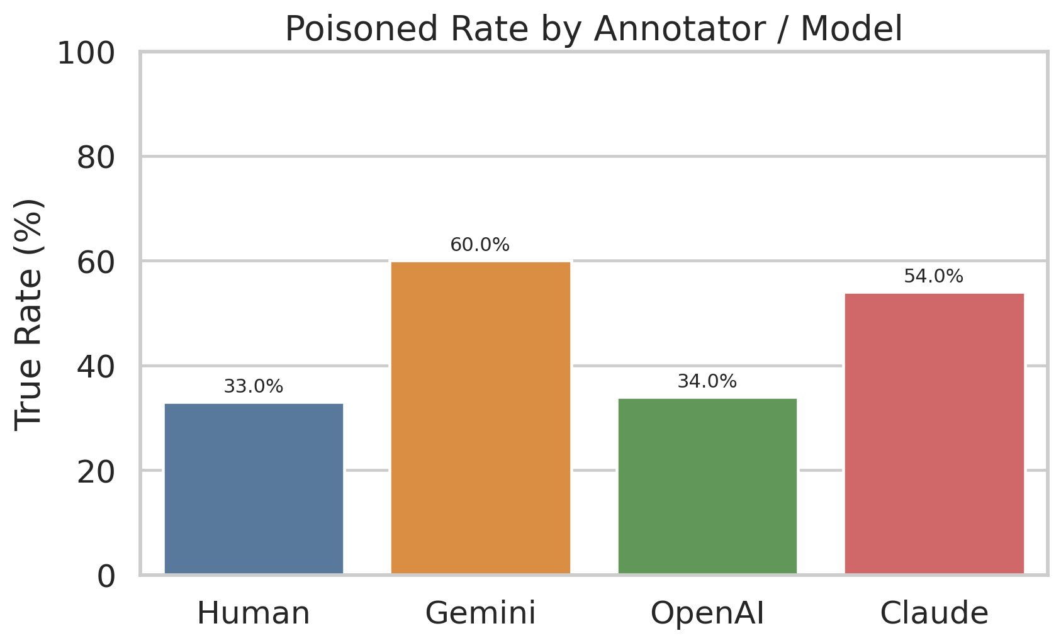
Second, we measured agreement with human labels. We considered two levels of agreement: poisoned-label accuracy and attack-level accuracy. Poisoned-label accuracy checks whether the model correctly identifies a video as clean or unsafe compared with human annotation. Attack-level accuracy is stricter and measures whether the predicted category exactly matches the human label among None, Semantic, Logic, and Decision. These two metrics together allow us to distinguish between models that can roughly detect abnormal samples and models that can also classify the specific failure type correctly.

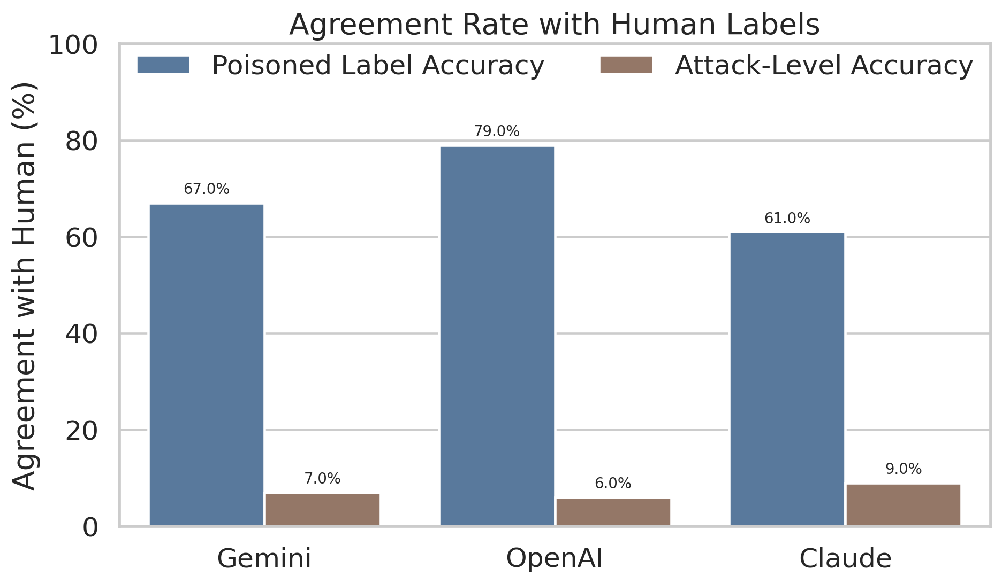
Third, we evaluated score-level consistency by computing the root mean square error (RMSE) between model scores and human scores. We report both the overall RMSE and the RMSE of each score component, including semantic, logical, decision, and final_score. This analysis is important because even when two annotators assign the same discrete attack label, they may still differ substantially in their severity estimation. Lower RMSE indicates that the model is closer to human judgment not only in categorical labels but also in fine-grained scoring.

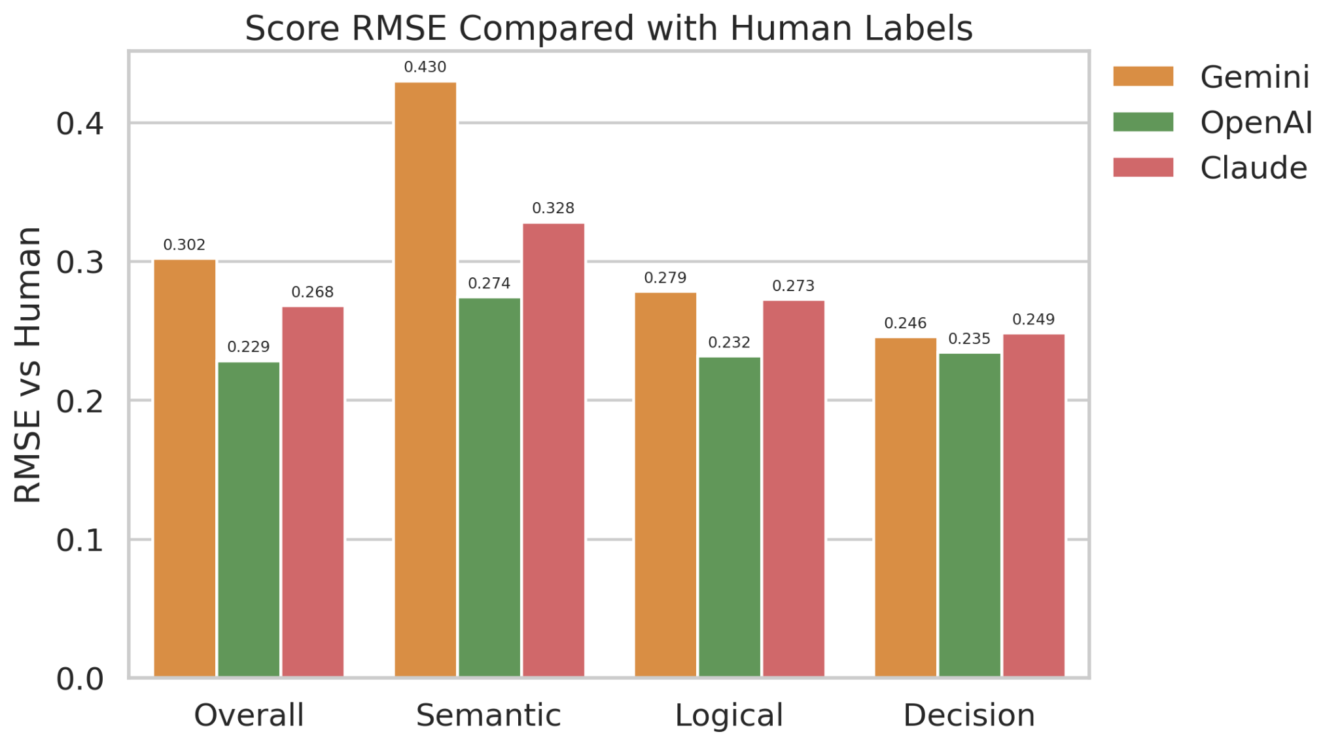

Prompt Design Improvement

To improve the reliability of LLM-based labeling, we refined the original prompt after observing model-specific biases in the first evaluation. The initial prompt provided the same annotation guideline to all models and required a fixed CSV-style output, but the results showed that different models interpreted the criteria differently. Gemini tended to over-label samples as poisoned, OpenAI was relatively conservative, and Claude sometimes produced unstable formatting or explanatory text outside the required structure.

Therefore, the improved prompt kept the same task definition, label schema, and scoring rules, but adjusted the instructions for each model. For Gemini, we raised the threshold for assigning `is_poisoned = True`, emphasizing that blur, fog, glare, or general visual degradation should not be treated as an attack unless they clearly affect traffic-relevant objects, lane cues, road boundaries, or driving decisions. For OpenAI, we reduced excessive conservatism by reminding the model that persistent and traffic-relevant corruption should be labeled as poisoned even if the scene remains partially understandable. For Claude, we mainly strengthened the output constraint by requiring only one valid CSV row without extra explanation.

These prompt changes were designed to make the LLM outputs more applicable to the annotation task rather than simply more verbose. The goal was to align model judgments with the human labeling guideline, reduce systematic over-detection or under-detection, and ensure that the outputs could be normalized and compared across models under the same evaluation metrics.

Improved LLM Evaluation

After prompt refinement, we re-ran the LLM evaluation and compared the improved results with the original outputs. The comparison focuses on whether the new prompts reduced model bias, improved agreement with human labels, and produced severity scores closer to human judgment.

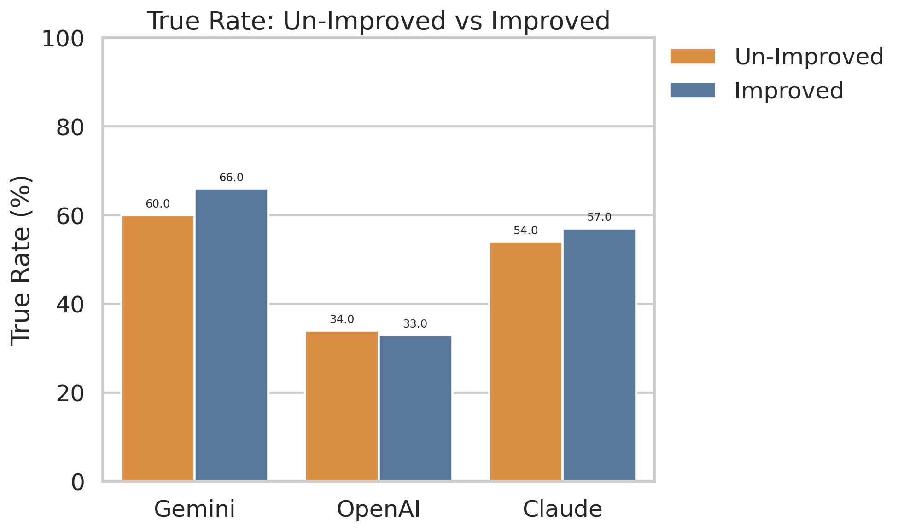

The true-rate comparison shows that prompt refinement changed each model’s overall labeling tendency. This metric is important because a model may appear sensitive to attacks simply by labeling too many samples as poisoned. The results show that prompt changes can noticeably shift model behavior, but the effect is model-dependent. OpenAI produced the poisoned rate closest to the human annotation distribution, while Gemini and Claude still showed stronger tendencies to over-detect poisoned samples.

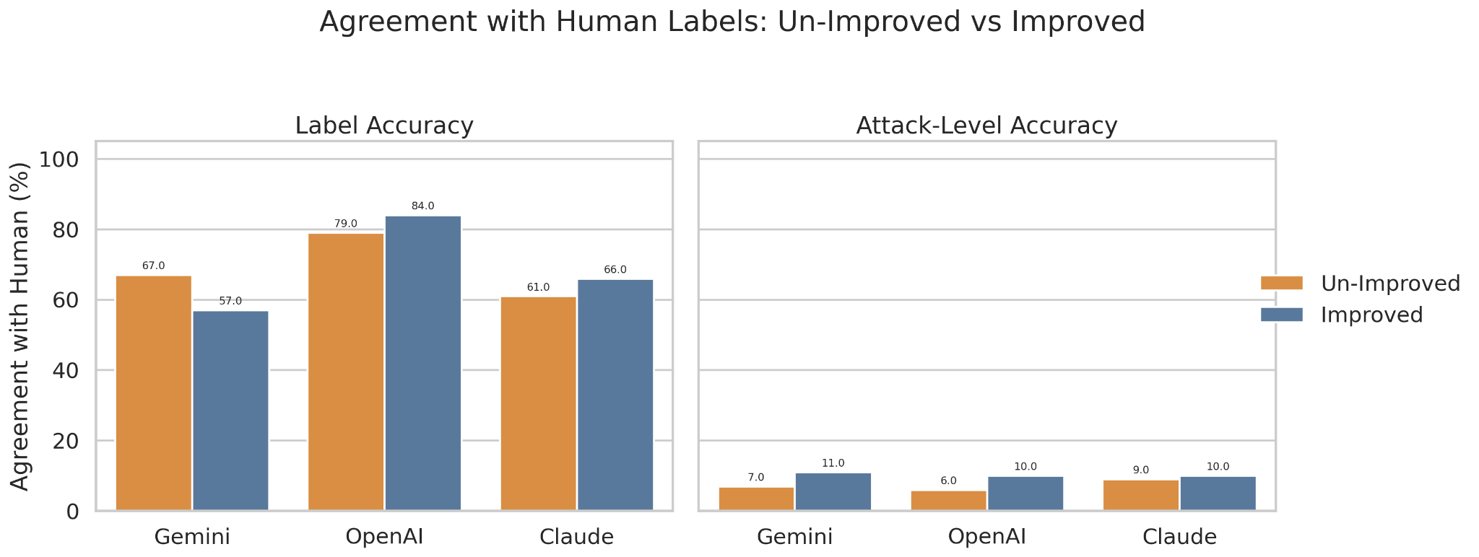

We then compared agreement with human labels before and after improvement. Poisoned-label accuracy measures whether the model correctly identifies clean versus poisoned videos, while attack-level accuracy requires an exact match among None, Semantic, Logic, and Decision. The improved OpenAI evaluator achieved the strongest binary agreement with human labels. However, attack-level accuracy remained low across all models, suggesting that identifying the exact type of failure is more difficult than detecting whether a video is abnormal.

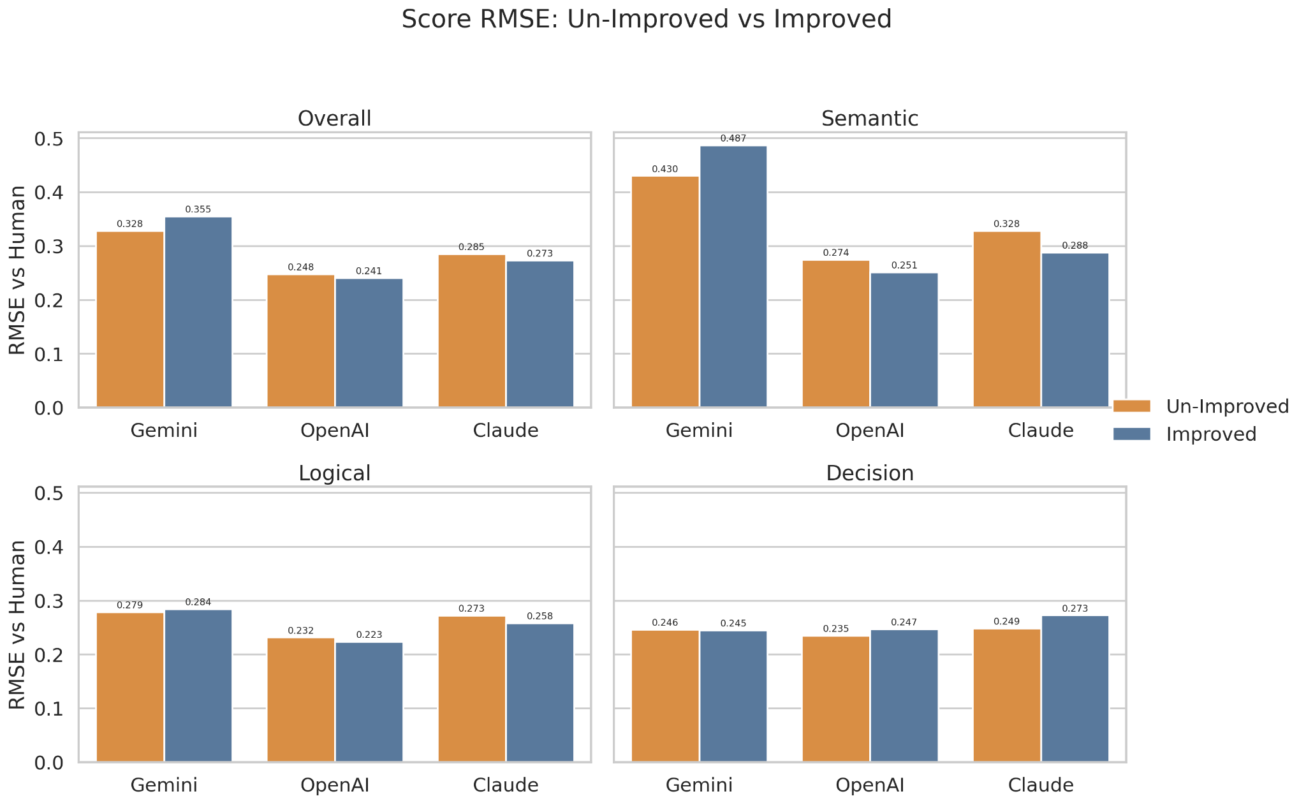

Finally, RMSE was used to compare model scores with human scores across semantic, logical, and decision dimensions. This evaluates whether the model’s severity estimation is close to human judgment. The results show that better binary classification does not always imply better score calibration. Among the six evaluated settings, improved OpenAI achieved the lowest overall RMSE, making it the most balanced automated evaluator.

Overall, prompt refinement helped reduce some model-specific bias, but it did not fully solve the reliability problem of LLM-based evaluation. The remaining limitations include manually tuned prompts, non-identical model input pipelines, subjective human labels, low attack-level agreement, and API cost constraints. Future work could use multiple human annotators, systematic prompt search, rule-based visual checks, and unified frame-based inputs across all models.

Final Model Selection
Based on poisoned-label accuracy, attack-level accuracy, true-rate distribution, and score-level RMSE, we select the improved OpenAI evaluator as the final automated model. It achieved the highest binary agreement with human labels, the lowest overall RMSE, and a poisoned rate closest to the human annotation distribution. Although its attack-level accuracy remained limited, it provided the most balanced performance among the six evaluated settings.

Conclusion
This project developed a human-centered safety evaluation framework for generated autonomous driving videos under physically conditioned attacks. We annotated 100 multi-view driving videos and compared human labels with three LLM-based evaluators: Gemini, OpenAI, and Claude. The evaluation considered poisoned detection, attack-level classification, and numerical severity scoring.

The results show that LLMs can support safety evaluation, but their reliability depends strongly on model choice and prompt design. Gemini tended to over-detect attacks, Claude improved after stricter formatting constraints, and OpenAI achieved the most balanced performance after prompt refinement. Improved OpenAI was selected as the final model because it had the closest poisoned rate to human annotation, the highest binary agreement, and the lowest overall RMSE.

However, LLM-based evaluation is not yet sufficient to replace human judgment. Attack-level accuracy remained low across all models, showing that distinguishing semantic, logical, and decision-level failures is harder than detecting abnormal samples. Future work should combine multiple human annotators, systematic prompt optimization, unified visual inputs, and rule-based checks for object persistence, lane consistency, motion plausibility, and ego-vehicle behavior. Overall, prompt-refined LLMs can be useful assistants, but the most reliable approach remains a hybrid framework combining human judgment, structured prompts, and automated visual consistency checks.

References
Caesar, H., et al. (2020). nuScenes: A multimodal dataset for autonomous driving. Proceedings of the IEEE/CVF conference on computer vision and pattern recognition.
Gao, R., et al. (2024). MagicDrive: Street View Generation with Diverse 3D Geometry Control. International Conference on Learning Representations.
Liu, Y., et al. (2023). G-Eval: NLG Evaluation using GPT-4 with Better Human Alignment. arXiv preprint arXiv:2303.16634.
Wang, X., et al. (2023). Drivedreamer: Towards real-world-driven world models for autonomous driving. arXiv preprint arXiv:2309.09777.
Wen, Y., et al. (2024). Panacea: Panoramic and controllable video generation for autonomous driving. Proceedings of the IEEE/CVF Conference on Computer Vision and Pattern Recognition.
Zheng, L., et al. (2023). Judging LLM-as-a-Judge with MT-Bench and Chatbot Arena. arXiv preprint arXiv:2306.05685.

Appendix

Code is in github repository: https://github.com/XingjiaYang/AI6102_NTU

